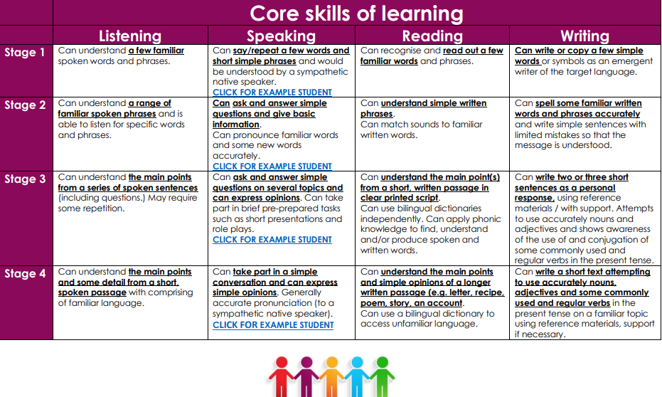 NB. Stages 1-4 equates to Year 3-6.

