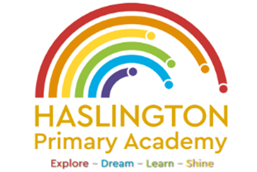

Haslington Primary Academy: School Council
Minutes of Meeting: Tuesday 10th October 2023
In Attendance: Mrs Donnelly, Adelyn, Joseph, Robyn, Erin, Oliver, Lily-May, King, Violet, Ella, Archie, Lyla, Elllie, Taylor, Louie, Imogen, Finley, Iona, Oliver.
Apologies: N/A
All children are welcomed to the meeting and reminded of meeting protocol, e.g. raising hand to speak, being respectful when listening to other people’s views and ideas and showing empathy for those around us. Children are reminded to take notes in their School Council Meeting Book so they can feedback to their class.
Discussion Item | Outcome
Expectations of school council | - Mrs Donnelly discussed the roles and responsibilities of the school council and the type of activities that woul e undertaken over the course of the year
Anti-Bullying Week/Odd Socks Day | - Children to design posters to promote Anti-Bullying Week  - Children discussed Odd Socks Day and what this represents – posters to be designed next week
AOB | - Children raised concerns about the hygiene in the toilets (both boys and girls) stating that other children sometimes don’t flush the toilets, wee on the seats and drip water all over the floor. Mrs Donnelly said that we would carry out an assembly on hygiene and the children suggested that posters are made. Children also were worried about the paint chipping off the wall by the sink in the Y5/6 girls toilets. All children would like mirrors in the toilets as well. Mrs Donnelly said she would speak to Mrs Mitchell about this.  - Children raised concerns about the food on the floor after a lunch time and agreed this needs to be addressed. Mrs Donnelly said that the staff are aware of this and we could work together on some actions to improve this. The children suggested more bins in the dining hall.  - Children suggested a donations bucket coud be in school to help raise funds for items we do not have.

