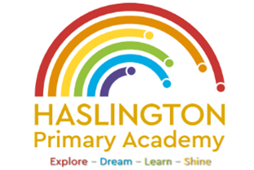

Haslington Primary Academy: School Council
Minutes of Meeting: Tuesday 8th December 2023
In Attendance: Mrs Donnelly, Adelyn, Joseph, Robyn, Erin, Oliver, Lily-May, King, Violet, Ella, Archie, Lyla, Ellie, Taylor, Louie, Imogen, Finley, Iona, Oliver.
Apologies: N/A
All children are welcomed to the meeting and reminded of meeting protocol, e.g. raising hand to speak, being respectful when listening to other people’s views and ideas and showing empathy for those around us. Children are reminded to take notes in School Council Meeting Book so they can feedback to their class.
Discussion Item | Outcome
Christmas Fayre | - Mrs Donnelly confirmed that she had shared the Christmas Fayre suggestions with Mrs Morris  - Many of the suggestions have been taken on board and all children are looking forward to the fayre
Toilets | - The children have continued to raise concerns around the hygiene in the toilets: wee on the seats, where a lock has been moved the children can see through the old holes (can we fill the holes?), mirrors to be installed, check the locks to ensure they all lock properly, wet walls in the UKS2 girls bathroom (possible condensation).  - Mrs Donnelly said that she would speak to Mr Clewes and Mr Boulton about their concerns.  - School Council to support Mrs Donnelly with the whole school assembly on Monday
AOB: Traffic lights across the road from school | - Children were concerned that there are occasions where the crossing lights are not working.  - Mrs Donnelly said she will have a look and see if there is a contact for the council to support us with safety outside of school.
AOB: Lunch hall | - Children are concerned about the mess on the floor and Iona said she felt sorry for the staff that have to clean this up.  - The School Council agreed this would be a focus for us in January.

