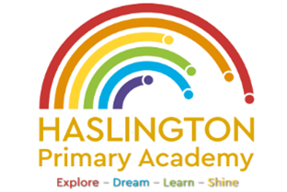

Haslington Primary Academy: School Council
Minutes of Meeting: Tuesday 24th November 2023
In Attendance: Mrs Donnelly, Adelyn, Joseph, Robyn, Erin, Oliver, Lily-May, King, Violet, Ella, Archie, Lyla, Ellie, Taylor, Louie, Imogen, Finley, Iona, Oliver.
Apologies: N/A
All children are welcomed to the meeting and reminded of meeting protocol, e.g. raising hand to speak, being respectful when listening to other people’s views and ideas and showing empathy for those around us. Children are reminded to take notes in School Council Meeting Book so they can feedback to their class.
Discussion Item | Outcome
Christmas Fayre | - We discussed the upcoming fayre and the children talked about the types of activities/stalls they would like to see: opportunities to buy colouring activities, books, craft areas, throwing sponges at adults, glitter tattoos, face paint, Santa, hook a duck, DVD stall, games to play, Christmas jumper stall, Christmas hat stall, Pokemon stall, lucky dip, signs such as ‘the best grandad’, wine stall, fake snow and a place to buy cards.
Thank you | - Mrs Donnelly thanked the council for their support with Children in Need and Anti-Bullying Week.
AOB | - N/A

