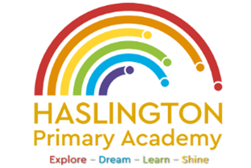

Haslington Primary Academy: School Council
Minutes of Meeting: Tuesday 9th January 2024
In Attendance: Mrs Donnelly, Adelyn, Joseph, Robyn, Erin, Oliver, Lily-May, King, Violet, Ella, Archie, Lyla, Ellie, Taylor, Louie, Imogen, Finley, Iona, Oliver.
Apologies: N/A
All children are welcomed to the meeting and reminded of meeting protocol, e.g. raising hand to speak, being respectful when listening to other people’s views and ideas and showing empathy for those around us. Children are reminded to take notes in School Council Meeting Book so they can feedback to their class.
Discussion Item | Outcome
Thank you | - Thank you to all the children who supported Mrs Donnelly in the assembly regarding the hygiene in the toilets/
Expectations of behaviour | - Mrs Donnelly discussed the behaviour expectations of the school council and how the children should be setting a good example to the other children. They are seen as a role model to the other children and need to show themselves in a good light.
Lunch Hall | - Mrs Donnelly confirmed that she had shared the Christmas Fayre suggestions with Mrs Morris  - Many of the suggestions have been taken on board and all children are looking forward to the fayre
Toilets | - The children would like to know when the mirrors will be going up in the children’s toilets.  - Mrs Donnelly said she would chase this up with Mr Clewes and Mr Boulton.
AOB: | - World Book Day – the children discussed ideas for WBD and Mrs Donnelly said there would be a survey going out to parents/carers/guardians so we could gather their views.

