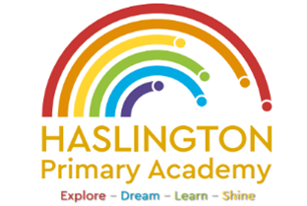

Haslington Primary Academy: School Council
Minutes of Meeting: Tuesday 12th March 2024
In Attendance: Mrs Donnelly, Adelyn, Joseph, Robyn, Erin, Oliver, Lily-May, King, Violet, Ella, Archie, Lyla, Ellie, Taylor, Louie, Imogen, Finley, Iona, Oliver.
Apologies: N/A
All children are welcomed to the meeting and reminded of meeting protocol, e.g. raising hand to speak, being respectful when listening to other people’s views and ideas and showing empathy for those around us. Children are reminded to take notes in School Council Meeting Book so they can feedback to their class.
Discussion Item | Outcome
Welcome | - Welcome to Miss Barber who will be joining us for some of our meetings.
Oral hygiene | - Mrs Donnelly shared news about oral hygiene that she had seen on the news stating that primary school children have the worst oral hygiene in 20 years.  - The council discussed when we should brush our teeth and how to can make our teeth more healthy.  - The children are going to carry out some pupil voice and feedback the results in the next meeting.  - Mrs Donnelly and the council are going to write to a local dentist and ask for some support about improving oral hygiene such as brushing teeth at lunch time.
AOB: | - N/A

