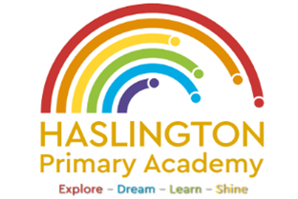

Haslington Primary Academy: School Council
Minutes of Meeting: Tuesday 27th February 2024
In Attendance: Mrs Donnelly, Adelyn, Joseph, Robyn, Erin, Oliver, Lily-May, King, Violet, Ella, Archie, Lyla, Ellie, Taylor, Louie, Imogen, Finley, Iona, Oliver.
Apologies: N/A
All children are welcomed to the meeting and reminded of meeting protocol, e.g. raising hand to speak, being respectful when listening to other people’s views and ideas and showing empathy for those around us. Children are reminded to take notes in School Council Meeting Book so they can feedback to their class.
Discussion Item | Outcome
World Book Day | - The council discussed the feedback from the parents questionnaire and how we are going to promote reading this year.  - The children decided that staff and pupils could dress up in their favourite costume, lounge wear or Pjs.  - Each class will be able to carry out their own activities to promote the love of reading rather than having a whole school focus.  - Mrs Donnelly has arranged a ‘live’ author event for the children to take part in online with their class  - All children to contribute something to the new display and make a story box which shows their favourite book scene.
AOB: | - N/A

