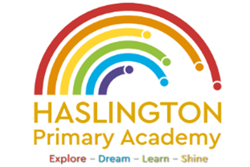

**Haslington Primary Academy: School Council**  
**Minutes of Meeting: Wednesday 2nd April**

In Attendance: Miss de la Haye, Darwin C, Will T, Lily L, Kobi J, Jasmine W, Jack R-W, Sophie M, Harvey L, Hallie M, Ugo O, Edward H, Jim L-M-Y, Ellie P, Harry W

Apologies: Oliver P, Elsie P

All children are welcomed to the meeting and reminded of meeting protocol, e.g. raising hand to speak, being respectful when listening to other people’s views and ideas and showing empathy for those around us. Children are reminded to take notes in School Council Meeting Book so they can feedback to their class.

|  |  |
| --- | --- |
| Discussion Item | Outcome |
| Welcome | * Miss de la Haye introduced and handed over to Carolyn from the RSPCA. |
| Litter | * Children discussed litter, what it is and were it comes from. Children learned about how long things take to decompose and the effect litter has on wildlife around school. |
| Litter Pick | * Children took part in a litter pick around school. There was not a lot of litter and children decided we are quite a clean school. |
| AOB: | * Children would like to create posters to put on the bins to encourage peers to stop littering. |