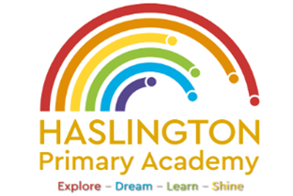

**Haslington Primary Academy: School Council**  
**Minutes of Meeting: Friday 14th March**

In Attendance: Miss de la Haye, Darwin C, Will T, Lily L, Kobi J, Jasmine W, Jack R-W, Sophie M, Harvey L, Hallie M, Ugo O, Edward H, Jim L-M-Y, Ellie P, Harry W, Elsie P, Oliver P

Apologies: N/A  
All children are welcomed to the meeting and reminded of meeting protocol, e.g. raising hand to speak, being respectful when listening to other people’s views and ideas and showing empathy for those around us.

|  |  |
| --- | --- |
| Discussion Item | Outcome |
| Welcome | * Miss de la Haye introduced the session and children had chance to feedback anything from their classes that had been raised since the last school council meeting. Nothing new was raised. |
| Pride for school | * Children discussed how we could show pride for school. Discussion points included wearing our correct uniform, respecting equipment and not dropping litter. |
| Litter | * Discussion of why litter is bad and how we can keep our school clean and tidy. Children encourage their peers to use the bins around school and the recycling bins in the classrooms. |
| AOB: | * Children will focus on litter and keeping the school clean and tidy. |