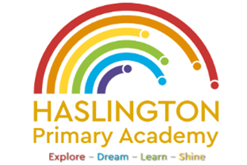

**Haslington Primary Academy: School Council**  
**Minutes of Meeting: Friday 28th February**

In Attendance: Miss de la Haye, Darwin C, Will T, Lily L, Kobi J, Jasmine W, Jack R-W, Sophie M, Harvey L, Hallie M, Ugo O, Edward H, Jim L-M-Y, Ellie P, Harry W, Elsie P

Apologies: Oliver P  
All children are welcomed to the meeting and reminded of meeting protocol, e.g. raising hand to speak, being respectful when listening to other people’s views and ideas and showing empathy for those around us. Children are reminded to take notes in School Council Meeting Book so they can feedback to their class.

|  |  |
| --- | --- |
| Discussion Item | Outcome |
| Welcome | * Miss de la Haye introduced the session and children had chance to feedback anything from their classes that had been raised since the last school council meeting. |
| Football | * Children’s classmates had been also putting forward ideas about how to bring back football. Children will continue campaign to allow football at lunch times. |
| World Book Day | * Discussion of World Book Day coming up. Children discussed why it is important to celebrate World Book Day. Edward H discussed that it helps show a passion for reading and Darwin C expressed that she likes reading books with fun characters. * Ellie P suggested the school council could help advertise World Book Day. * Children spent the rest of the session creating posters for World Book Day. |
| AOB: | * Children will continue campaign for football. Children would like to discuss respecting the school environment and showing pride for our school. |